**OVER AND PARTITION BY:**

The SQL partition by expression is a subclause of the over clause, which is used in almost all invocations of window functions like avg(), min() and rank(). As many readers probably know, window functions operate on window frames which are sets of rows that can be different for each record in the query result. This is where the SQL partition by subclause comes in: it is used to define which records to make part of the window frame associated with each record of the result.

**Example 1:**

With empty over

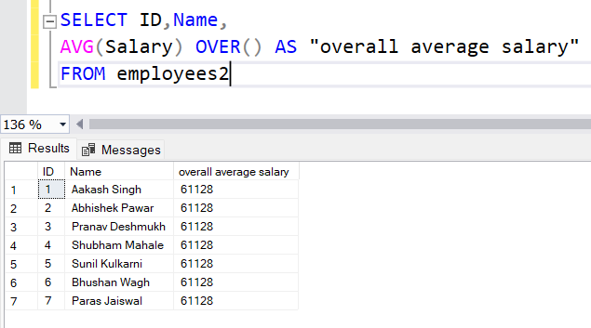

**Example 2:**

With over and partion by

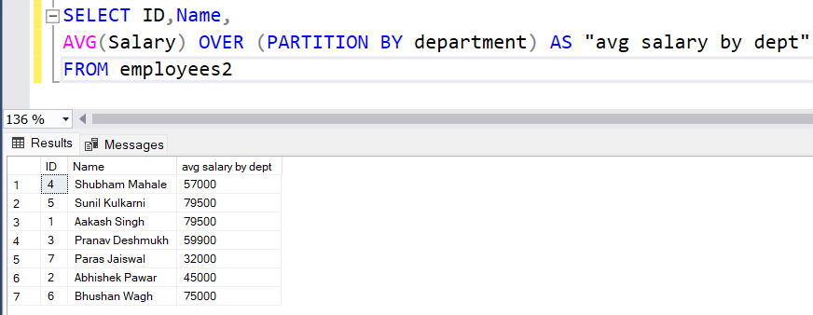

**Example 3:**

This example has both empty over and over with partition by

